

Faculty of Computer Science and Mathematics

Universiti Malaysia Terengganu

LAB REPORT

CSE3023 Web-Based Application Development

Name | Wai Pei Yuen
Matric No. | S74991
Semester | 2025/26-2
Lab Report | 1
Demonstrator | Ts. Dr. Wan Nural Jawahir Hj Wan Yussof

Exercise:
Full source code:
1. Correct creation of Servlet (GreetingServlet)
GreetingServlet.java
import java.io.IOException;
import java.io.PrintWriter;
import javax.servlet.ServletException;
import javax.servlet.http.HttpServlet;
import javax.servlet.http.HttpServletRequest;
import javax.servlet.http.HttpServletResponse;
import javax.servlet.RequestDispatcher;

/**
*
* @author wpy92
*/
public class GreetingServlet extends HttpServlet {

/**
* Processes requests for both HTTP <code>GET</code> and <code>POST</code>
* methods.
*
* @param request servlet request
* @param response servlet response
* @throws ServletException if a servlet-specific error occurs
* @throws IOException if an I/O error occurs
*/
protected void processRequest(HttpServletRequest request, HttpServletResponse response)
throws ServletException, IOException {
response.setContentType("text/html;charset=UTF-8");
try (PrintWriter out = response.getWriter()) {
/* TODO output your page here. You may use following sample code. */
out.println("<!DOCTYPE html>");
out.println("<html>");
out.println("<head>");
out.println("<title>Servlet GreetingServlet</title>");
out.println("</head>");
out.println("<body>");
out.println("<h1>Servlet GreetingServlet at " + request.getContextPath() + "</h1>");
out.println("</body>");
out.println("</html>");
}
}

// <editor-fold defaultstate="collapsed" desc="HttpServlet methods. Click on the + sign on the left to edit the code.">
/**
* Handles the HTTP <code>GET</code> method.
*
* @param request servlet request
* @param response servlet response
* @throws ServletException if a servlet-specific error occurs
* @throws IOException if an I/O error occurs
*/
@Override
protected void doGet(HttpServletRequest request, HttpServletResponse response)
throws ServletException, IOException {

// Get parameter "name"
String name = request.getParameter("name");

// Check if null or empty
if(name == null || name.isEmpty()) {
name = "Guest";
}

// Send data to JSP
request.setAttribute("username", name);

// Forward to JSP
RequestDispatcher dispatcher = request.getRequestDispatcher("greeting.jsp");
dispatcher.forward(request, response);
}

/**
* Handles the HTTP <code>POST</code> method.
*
* @param request servlet request
* @param response servlet response
* @throws ServletException if a servlet-specific error occurs
* @throws IOException if an I/O error occurs
*/
@Override
protected void doPost(HttpServletRequest request, HttpServletResponse response)
throws ServletException, IOException {
processRequest(request, response);
}

/**
* Returns a short description of the servlet.
*
* @return a String containing servlet description
*/
@Override
public String getServletInfo() {
return "Short description";
}// </editor-fold>

}

greeting.jsp
<%--
Document : greeting.jsp
Created on : Apr 2, 2026, 4:59:31 AM
Author : wpy92
--%>

<%@ page import="java.util.Date" %>

<%@page contentType="text/html" pageEncoding="UTF-8"%>
<!DOCTYPE html>
<html>
<head>
<meta http-equiv="Content-Type" content="text/html; charset=UTF-8">
<title>Greeting Page</title>
</head>
<body>
<h1>Hello, <%= request.getAttribute("username") %>!</h1>

<p>
<%
Date currentDate = new Date();
out.println("<p>Current date and time is " + currentDate.toString() + "</p>");
%>

<% response.setIntHeader("Refresh", 5); %>
</body>
</html>

2. Correct handling of request parameter (name) with default value (Guest)
Source code:
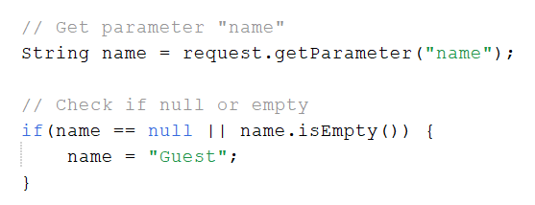
Result 1
If name entered:
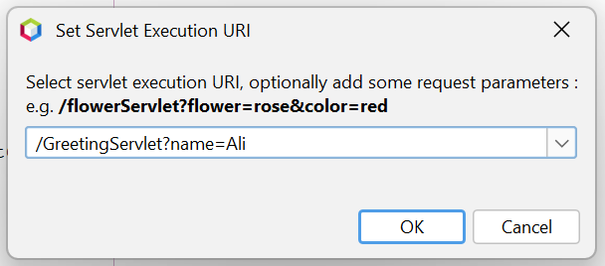

Output:
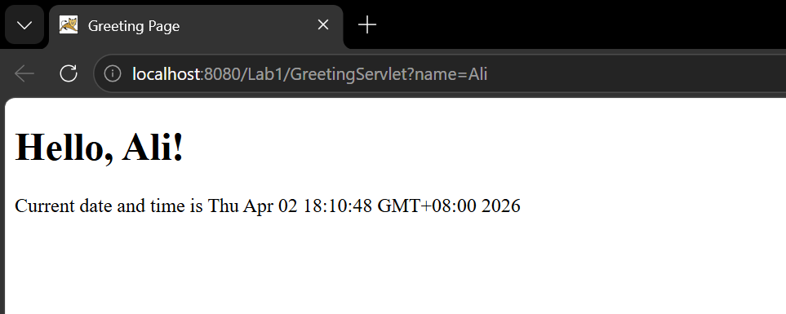
Result 2:
If name is not entered:
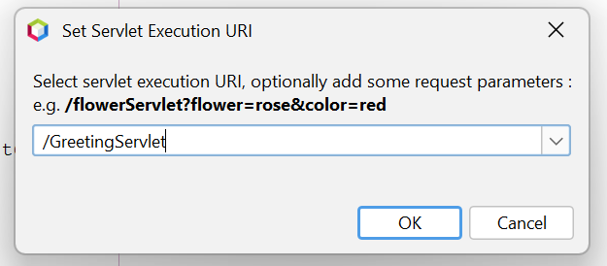

Output:
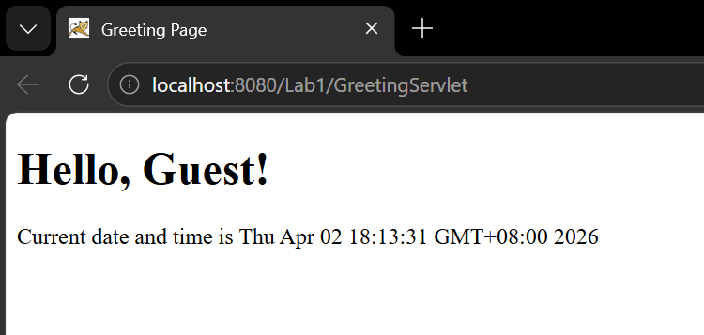

3. Successful forwarding from Servlet to JSP (greeting.jsp)

4. Correct display of dynamic content (name and current date/time) in JSP

Source code:
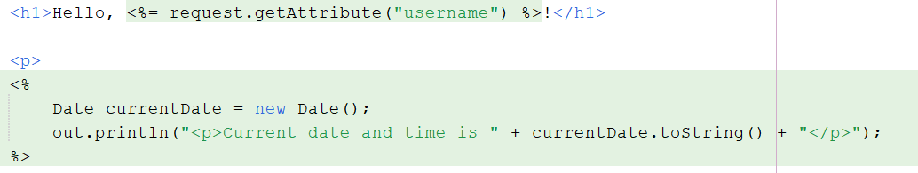

Output:
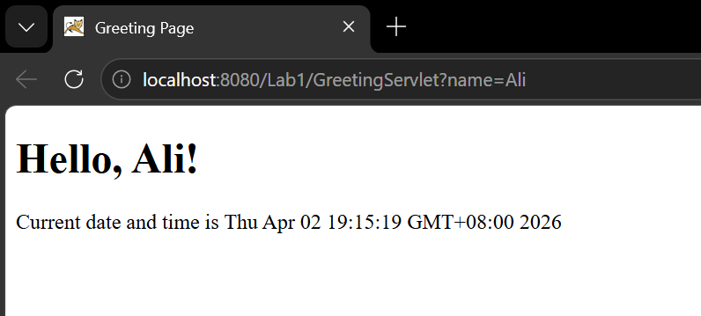

5. Implementation of auto-refresh functionality (every 5 seconds)
Source code:

Result 3:
The date and time will update automatically every 5 seconds.

Output:
